We are pleased to make a complete Onity RFID contactless locking system proposal for your property.
我们很高兴为您推荐完整的Onity RFI 技术的非接触式门禁系统。
Onity locking systems can be found in 115 countries and over 4 million hotel rooms. Onity is approved and recommended
by 250 of the most prestigious International Hotel Chains worldwide; among others our customer list includes Accor,
Marriott, Intercontinental Hotels Group, Hilton, Rezidor, Kempinski, Wyndham, Starwood, Hyatt, Meliá, etc.
Onity 门禁系统用于115 个国家超过400 万间酒店客房。Onity 门禁系统被全球250 个知名的连锁酒店集团推荐和认可；
其中我们的客户名单包括雅高集团、万豪酒店、洲际酒店集团、希尔顿，Rezidor，凯宾斯基、喜达屋、凯悦、温德姆，
梅里亚等。
Onity is a Global Technological Solutions Provider for the hospitality industry, with more than 25 years of experience.
The company’s ever-expanding family of electronic solutions today includes Electronic Locks, In-room Safes, Minibars
and Energy Management systems.
Onity 是酒店行业的全球技术解决方案提供商，拥有超过25 年的经验。公司不断扩大的电子解决方案家庭今天包括电子门
锁、室内保险箱、迷你吧和能源管理系统。
We are proud to be the market leaders in technology and sales worldwide. As our long list of customers proves we have
a broad experience in providing advice, installation and service before and after the sale, which enables us to stay in
this prime position.
我们以成为本行业世界各地的技术和销售的市场领导者感到自豪。我们的长期客户名单证明我们所拥有的广泛经验，在提
供咨询，安装和售后服务，这使我们能够名列前茅。
At a competitive price, our systems’ combined strengths are:
• Excellent quality
• Ease of use
• Sound reliability
除了具有竞争力的价格外，我们的系统的综合优势包括：
•优良的品质
•使用方便
•高可靠性
For Onity “service” means many things, but primarily that hotel owners and users should receive total commitment
during supply, installation and training of the full system. We offer local technical support providing solutions to each
customer's individual needs.
对于Onity“服务”意味着很多东西，但主要是酒店业主和用户应在整个供应链上的总体承诺，安装和全系统培训。我们
提供本地化的技术支持，为每个客户的个性化需求提供解决方案。
We thank you in advance for your interest in our products and hope that we can soon add your vessel to our long list of
customers. Please do not hesitate to contact us if you have any questions or require additional information.
我们更要感谢您对我们的产品的兴趣，并希望我们能很快将您的船舶添加到我们的客户名单中。如果您有任何问题或需要
额外信息，请不要犹豫与我们联系。
We invite you to visit our website www.onity.com to find out more about our company and products.
欢迎访问我们的网站www.onity.com 找到更多关于公司和产品。
Yours sincerely
Andrew Wu

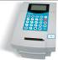
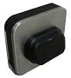
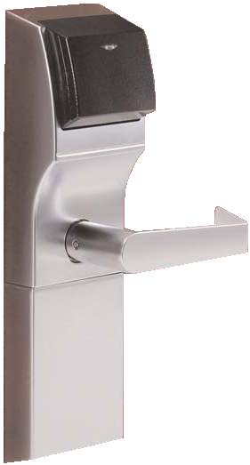
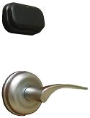
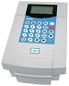
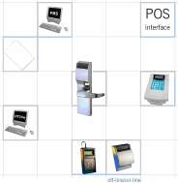
CONTACTLESS RFID ELECTRONIC LOCKING SYSTEM
非接触式 射频 电子锁系统
- Standalone or PC Based and Windows® compatible
与PC/Windows 系统兼容
- Designed for any hotel property size 适合任何大小居住区域
- Supports MiFare® and NFC technologies 支持 MiFare和近场科技
- Manages up to 10.000 rooms and 5.000 different master cards 支持多达1万间房间与5000种不同的主卡
- Up to 100 networked encoding stations 支持100个网络编码基站
- Staff time control 支持员工时间控制
- PMS & POS Interface

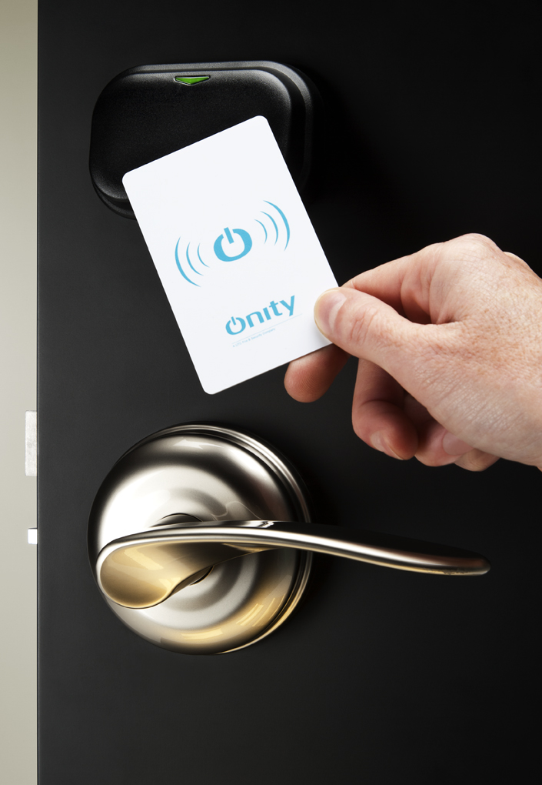 | ADVANCE Rfid Lock | - Contactless RFID reader modular lock with MiFare technology  - Non-volatile memory  - Records last 500 openings, including date and time  - LEDs to indicate lock status including low battery  - Features Office mode (free access) and "Do-Not-Disturb" function  - Anti-vandalism (no infrared LEDs, no slots, etc.)  - Satin Chrome finish  - Wing handle  - EURO lock case  - 非接触式RFID 阅读器模块锁Mifare 技  术  - 可擦写长久存储记忆体  - 记录最后500 个开锁，包括日期和时间  - LED 指示锁定状态，包括低电池报警  - 功能办公模式（免费接入）和“请勿打  扰”功能  - 防破坏（无红外线，无槽，等）  - 缎面镀铬  - 翼柄把手  - 欧标锁芯
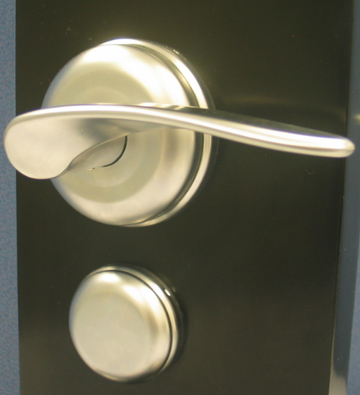 | Mechanical  Key Override  Option  额外的机械门锁  选配 | - Visible / Hidden  - Key Alike / Key Different / Master Keying  Final price depends on the size of the cylinder. This price is for standard cylinder (35x30)  - Visible / Hidden  - Key Alike / Key Different / Master Keying  . This price is for standard cylinder (35x30)  - 可见/隐藏  - 相同钥匙/不同钥匙/Master 钥匙  - 标准锁孔（35*30）
 | HT28 Smart  Software  HT28 智能软件 | - Windows® based software to manage and control Onity electronic locks  - - 基于Windows® 的Onity管理和控制电子门锁系统
 | Encoder for  MiFare cards  Mifare卡编码器 | - Encoder for ADVANCE Rfid lock keycards  - Compatible with any PMS system (when working with HT28 Smart software)  - Battery back-up  - Keeps in non volatile memory all the hotel card codes as PC backup  - Possibility to work in up to 10 different languages  - Incorporates 7 hot keys for the most frequently used functions  - RFID 锁钥匙卡编码器  - PMS 系统兼容（与ht28 智能软件配套）  - 备用电池  - 保持在长久存储记忆体的所有酒店卡代码作  为个人电脑备份  - - 可采用10 种不同的语言中工作

ONIC LOCKS |  |  | Quantity
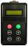 | Portable Programmer  手提式编程器 | - Data transfer link between front desk and locks, as well as safes and other off-line options  - Allows programming, retrieving the audit trail of the last openings, technical diagnosis, etc.  - Password protected  - Can open locks in emergency cases  - Allows uninterrupted front desk operation  - 前台和锁之间的数据传输链路，以及保险箱  和其他离线选项  - 允许编程，检索最后开口的审计线索，技术  诊断等  - 密码保护  - 在紧急情况下可以打开锁  - - 允许不间断的前台操作
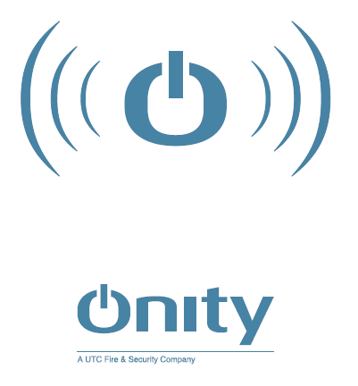 | RFID MiFare  1K Card  RFID MiFare 技术  1K 容量 卡 | - Contactless Mifare Classic ISO14443 cards  - 1K capacity divided in 16 sectors  - Allows multi-application  - Reusable and laminated  - With Onity logo design  - 非接触Mifare Classic ISO14443 卡  - 1K 容量划分为16 个扇区  - 允许多应用  - 可重复使用和层压  - - Onity 标志设计
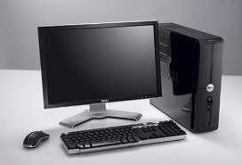 | PC  电脑 | - Server PC to host HT24w Onity Software  - W7/8 Pro Editions  服务器的电脑主机ht24w Onity 软件  - W7 / 8 专业版
 | Commissioning  服务 | - System set-up and Staff training  - Programming and set up access control  - 系统设置和员工培训  -编程和设置访问控制
 |  | Total Electronic Locking System

Total Card Energy Saver

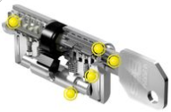 | Keys | - Upon masterkeying system  - General Master Key x6  - Individual Keys (267x3=801)  - 基于Masterkeying 系统  - 主钥匙 6把  - 区域钥匙3*5 把  - - 独立钥匙 302*3 把
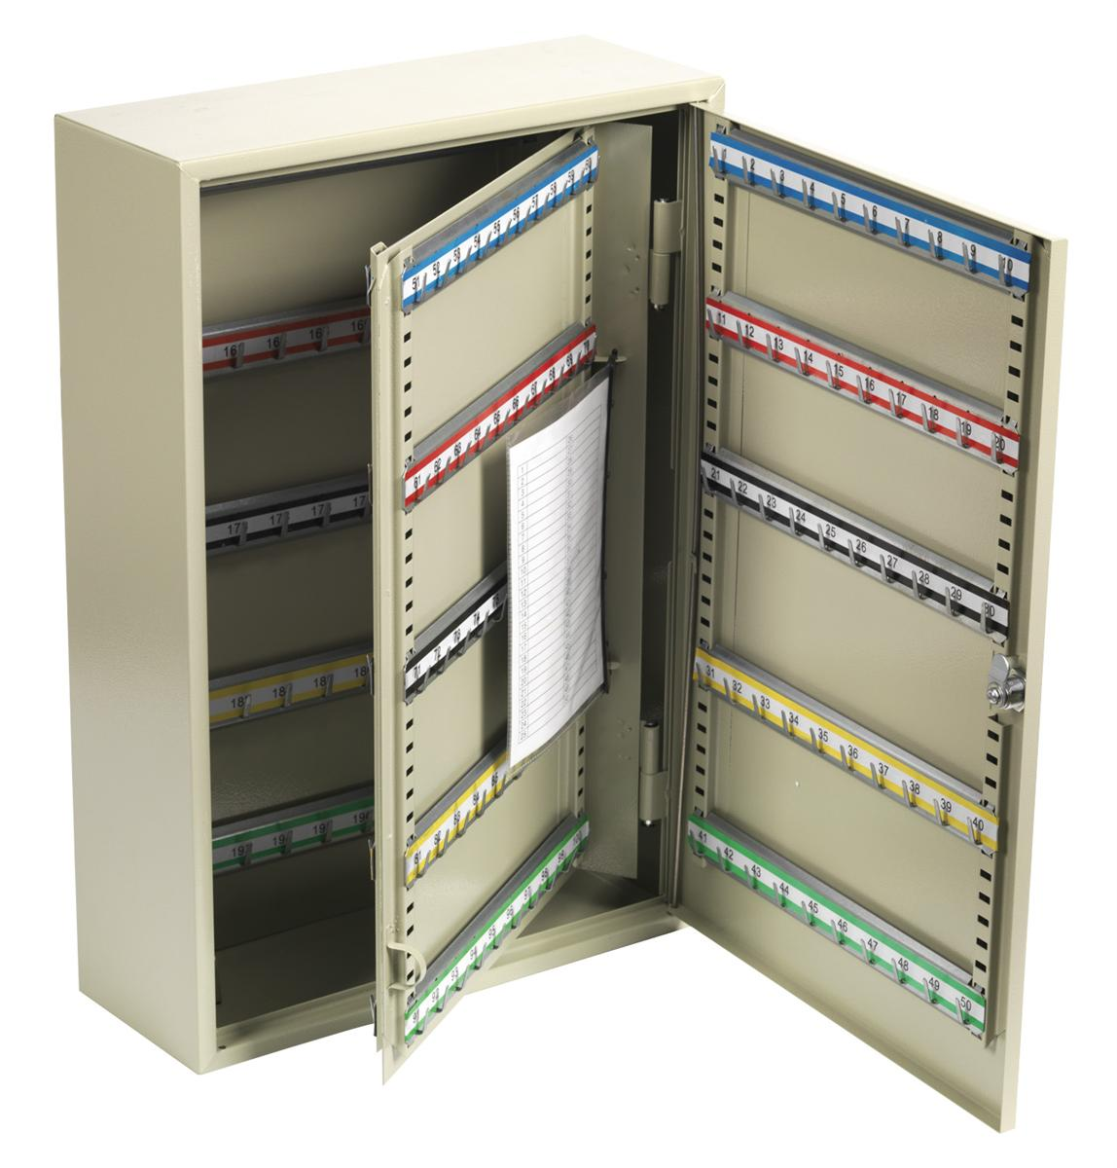 | Key Cupboard  钥匙柜 | - With 600 hooks  - -1 internal leaf  - 600 个挂钩  - 1 个内格

